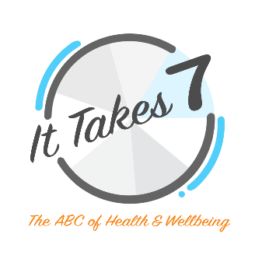
TEACHING NOTES

Learning intentions
Students understand:
- being healthy involves engaging in a range of healthcare practices
- we practice healthcare every day
- healthcare practice choices can influence how we think, learn and play

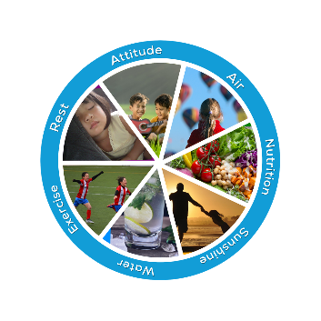
Student Engagement
Students:
- identify 7 holistic healthcare practices
- explain why certain healthcare practices are healthy or unhealthy
- choose to engage in a wide range of health promoting behaviours
- enjoy health quizzes, puzzles and activities
- complete personal and class health surveys
- create a personal collage health wheel
- investigate and research healthcare practices
- present their findings, with or without technology, making posters, brochures or student/teacher negotiated presentations

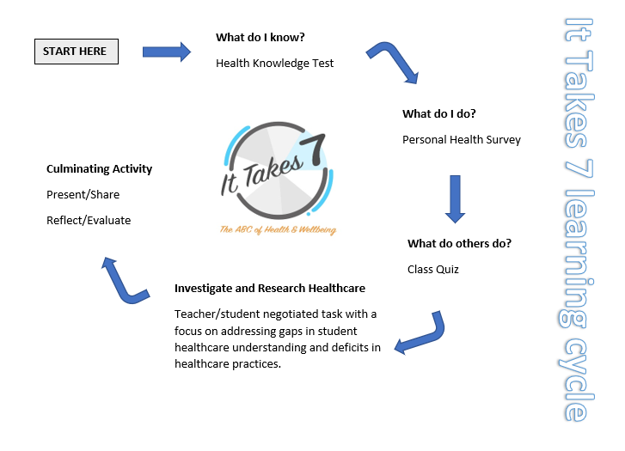
It Takes 7 Learning Cycle
The It Takes 7 learning cycle remains the same regardless of which age group you are planning to teach. This learning cycle should be repeated yearly so students can build layer upon layer of their health knowledge and practice.

Learning about and applying health principles follows a similar process to any creative discipline. In music we build on our knowledge of scales and rehearse them regularly to improve our performance. In art, we deepen our understanding of colour palettes so we can apply that knowledge to our artwork. Similarly, in healthcare, we need to deepen our understanding of the foundational elements of health so we can write personal health scripts and act them out accordingly.

Teacher Preparation
Running holistic healthcare units such as It Takes 7 are most effective when the teacher becomes a participant. Once you are familiar with the teaching sequence for students, come back and use this checklist to help you prepare for teaching your health unit.

Lesson 1: Introduction – be sure you are familiar with the acronymic saying: Attitude is the ANSWER is the ANSWER (Air, Nutrition, Sunshine, Water, Exercise, Rest).

Lesson 2: It Takes 7 Health Knowledge Quiz – know the answers.

Lesson 3: It Takes 7 Personal Health Survey – complete the Adult Health Survey, record your results on a Health Survey Results sheet. Analyse your results and record a plan on a Brainstorm Sheet. List ideas for how you intend to address gaps in your healthcare practices. This preparation will help you model the lesson and co-engage with your students.

Lesson 4: It Takes 7 Class Health Quiz – review the survey and see which questions are relevant to your class. The documents can be edited. Consider if you want to follow up this quiz with a maths activity, displaying your findings in graphs. Prepare a lesson to suit your students’ abilities.

Lesson 5: The Health Wheel – experiment with the health wheel tools and be familiar with how to upload and manipulate images. Check the troubleshooting points so you can deal with problems students may encounter when using the health wheel tool.

Lesson 6: Research and Investigations – fine tune how you want your unit to unfold. You may like to offer open-ended, limited or specific choices for class areas of health research and investigation. You will need to make decisions about presentation of their assignments and assessments.

Note:
It is important to be mindful that some students may have sensitivities regarding their personal health and wellbeing. Concerns in relation to allergies, disabilities, weight perceptions, sporting capabilities, etc may arise in class conversations. Plan ahead for managing these topics. Language choice is critical to alleviating any stigmas students may feel in relation to their size, shape or abilities. A reliable method for managing confronting situations is to shift the students’ focus back to the broad way we look at health. Remind students our healthcare goals are not so much about appearance as vitality, fitness, wellbeing and getting along with others. The aim is to live stronger, healthier more successful lives.

Teaching Sequence
Lesson 1: Introduction: Quiz, Song and Word Search
Lesson 2: Health Knowledge Quiz
Lesson 3: Student Health Survey
Lesson 4: Class Health Surveys
Lesson 5: Create Your Own Health Wheel/Poster
Lesson 6 Ongoing: Health Research
Present Findings

Student and Teacher Reflection

The teaching sequence is designed to:
- help you discover your students’ base line understanding of health
(Lessons 1 & 2)
- allow students to uncover gaps in their healthcare understanding and practices (Lessons 2-4)
- facilitate opportunities for students to research those gaps and reinforce ways to address them (Lesson 5, Lesson 6 ongoing)
- negotiate a way for students to present their findings
- encourage students to reflect on their engagement in the healthcare unit
Lesson 6 refers you to an example of an assessment rubric and student checklist. You can creatively adapt and personalize these documents to reflect your healthcare unit.

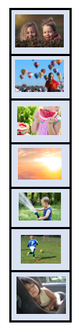
Lesson 1 (Part 1) HEALTH QUIZ
Introducing It Takes 7 - The ABC of health and wellbeing.
Write on the board or display digitally:
Attitude is the
A
N
S
W
E
R
Explain this saying will help you learn the ABC of health and wellbeing. Attitude is the first healthcare practice and ANSWER stands for another six healthcare practices. Ask the students to guess what the letters may stand for in the word ANSWER (Air, Nutrition, Sunshine, Water, Exercise, Rest). You may like to collect a series of images or items as prompts for when you ask the students to guess what each of the letters ‘A N S W E R’ represent (i.e., sunscreen, basketball, piece of fruit).

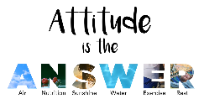
Check and reinforce answers using the video header on the It Takes 7 home page. When the image (right) comes around say out loud “Attitude is the ANSWER – A is for Air, N is for Nutrition, S is for Sunshine, W is for Water, E is for Exercise, R is for Rest!” Alternatively, you can use this video link.
MANAGING MY EMOTIONS
At the end of this lesson display an It Takes 7 Managing my Emotions poster in your classroom. You can personalise this poster using the document I have created for you. Simply replace some of the images with images of your own students engaging in healthcare practices. You may change the text. For example, ‘Year 2C check how you are going with each of these healthcare practices’.
RESEARCH OPTION – Lesson 6 Managing my Emotions
Students create their own poster to hang at home or in the classroom. Please retain our logo. Over the next 1-2 weeks students keep notes describing ‘when’ (date and time) and ‘why’ (the situation, the relevance) the poster was used to help balance their emotions. Describe ‘what’ happened next. Finally, write a short essay explaining ‘if and how’ the poster helped change their attitude and their healthcare behaviours.

Lesson 1 (Part 2) SONG: Attitude is the ANSWER
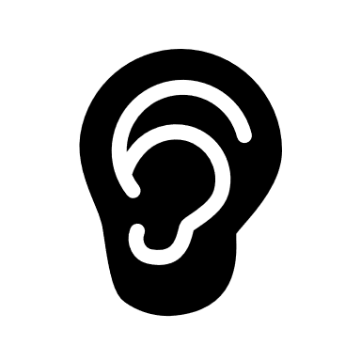MUSIC: Listen to and learn the song Attitude is the ANSWER.
Find some space in your classroom to create movements and actions to go with the song.
RESEARCH OPTION – Lesson 6 Creative Video
Students create a video of themselves dancing to the song Attitude is the ANSWER. Describe the process.

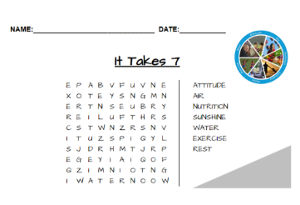
Lesson 1 (Part 3) WORD SEARCH
Complete the It Takes 7 Word Search Puzzle or have students create their own using the words: Attitude, Air, Nutrition, Sunshine, Water, Exercise, Rest.
RESEARCH OPTION – Lesson 6 The Body Puzzle
Students create word puzzles relating to individual healthcare elements. Students firstly engage in investigations on a ‘Kids Health’ website and learn about how body parts work to keep us healthy. Students take notes and then test their knowledge by answering relevant health quizzes on the website. If time permits, they can visit some other websites. When they have gathered enough information, they can create a Word Search puzzle relating to an It Takes 7 healthcare topic. Here are some suggestions:
- Attitude – emotions (happy, sad, angry, etc) or brain anatomy (cerebrum, brain stem, etc)
- Air – respiratory system (nose, lungs, breathe, etc) or the air cycle
- Nutrition – a list of fruit or vegetables; foods from the 5 food groups or the digestive system
- Sunshine –SunSmart reminders (hat, sunscreen, etc) or skin anatomy or solar words
- Water – words relating to drinking water or water sports or hygiene
- Exercise – sporting games or muscles or parts of the body or physical movements
- Rest – sleep and relaxation words or pets or hobbies
TASK: Students create a list of words for their topic. Go to Puzzlemaker and make a word search. They may like to create a piece of artwork to go with their word search. As an example, analyse this very clever student drawing showing what the brain needs to keep healthy. Encourage your students to use the It Takes 7 checklist. Ask: Is there one more thing you could add to the picture? Answer: Unjumble these letters RAI (Air). This exercise highlights the importance of having an ABC for health and wellbeing. Nothing is overlooked!
Puzzlemaker sites: AtoZteacherstuff for teachers, Puzzlemaker for students

Lesson 2 HEALTH KNOWLEDGE QUIZ
Complete an It Takes 7 Health Knowledge Quiz
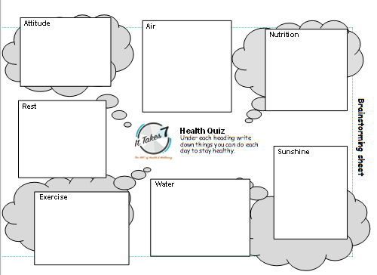
Prior learning activities allow students to express what they already know about a topic. They also provide teachers with insights into student misconceptions or gaps in their understanding. This data will provide orientation for the way you develop your healthcare unit, adopt cross curricular priorities and design assessment tasks.
Teachers make sure you know all the answers before giving this quiz to your students Answer sheets are provided.

These support documents may be helpful for running a short health knowledge quiz. You can choose or adapt one to suit your class. The Brainstorm sheet provides space for young students, prompted by a series of questions, to draw or record what they already know about healthcare. The Brainstorm sheet can also be used as a planning document for older students after completing their health survey.
It Takes 7 Brainstorm Sheet
It Takes 7 Health Quiz Yr 1-2 & It Takes 7 Health Quiz Yr 1-2 ANSWERS
It Takes 7 Health Quiz Yr 3-4 & It Takes 7 Health Quiz Yr 3-4 ANSWERS
RESEARCH OPTION – Lesson 6 Media Reviews
Visit 2-3 other health sites and read their tips for health and wellbeing on It Takes 7 healthcare topics. Use the wheel as a checklist to make sure all 7 aspects of healthcare are mentioned.
It is important to draw your students’ attention to which healthcare topics are highlighted in the literature and which ones are overlooked. Generally, diet and exercise are commonly featured as key healthcare elements, reinforcing the notion that these are the most important healthcare practices. Consider why it is important not to forget about other elements like ‘Air, Water, Rest’ which are our highest priority survival needs.
Australian Websites:
MUNCH & MOVE - food and exercise focus
LIVE LIFE WELL @ SCHOOL - food and exercise focus
HEALTHY KIDZ - food focus
United Kingdom website: HEALTH FOR KIDS is more holistic in its coverage of healthcare topics.

Lesson 3 PERSONAL HEALTH SURVEYS
Complete an It Takes 7 Personal Health Survey and record your results in the Pie Chart on the Health Survey Results Sheet
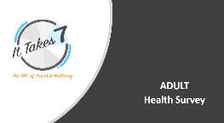
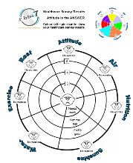
Teachers wanting to use this program with high school students can use or adapt this adult health survey for their class.

Teacher Preparation:
- Print off an It Takes 7 Health Survey Results Sheet.
- Complete the Adult Health Survey, in PowerPoint.
- Score your result and colour in your chart as you complete each section.
- Identify the healthcare practices you most need to address and on a Brainstorm Sheet consider how you might create supports in your life to improve on these practices (e.g. carry a water bottle, prepare meals in advance, determine some disciplines around technology).
- Consider how you may model this with your class.
Repeat this same process with your students. You may want to adapt this survey to suit your class level.


Students:
- Identify which healthcare practices they are best at, which are OK and which ones need the most improvement.
- Share their results with a partner or in small groups.
- Using a Brainstorm Sheet, make a plan for how they intend to address the gaps in their healthcare practices (e.g. have a drink at the end of each play time, carry a water bottle, eat fruit every day, don’t take technology to bed, read a book instead).
RESEARCH OPTION – Lesson 6 Health Journalling
Students journal their 7 healthcare practices for 1-2 weeks and analyse their progress. Alternatively, they journal the healthcare practices they need to improve on most. Brainstorm a series of questions to help with their reflection: What healthcare practices did I improve on? Were there areas where I slipped backwards? What helped me to do well? What circumstances worked against me?

Lesson 4 CLASS HEALTH QUIZ
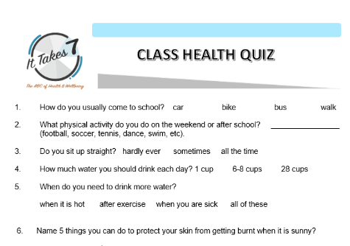
Complete the It Takes 7 Class Health Quiz
This is a general quiz that can be adapted to suit your class. After you have completed the Class Health Quiz, represent some of your findings using bar graphs.
Creating bar graphs can be demonstrated in a teacher directed lesson and followed up with students recording the bar graph in their workbooks.

Foundation – Year 2
- Show the students an example of a data chart like the one you are going to create together in this lesson. You may find this example helpful - tally and pictograph.
- Discuss the graph features: label (Count and Tally), variables (elephant, seal, lion, etc) and tally.
- Create a chart for this question from the IT7 Class Health Survey: How do you come to school? Establish the variables (car, bus, walk, drive).
- Model how to collect data. Ask the students to put up their hands in response to your questions. e.g. Do you come by bus? Do you walk? Etc. On your graph, record the tally by colouring in the boxes.
- Students then make a copy in their own workbooks.
Year 3-6
Following a similar lesson sequence outlined for Foundation - Year 2, revise the use of and creation of graphs reflecting your students’ prior knowledge. You may review line graphs, bar graphs, pie charts and Venn diagrams. Divide the class into several groups and allocate each group a question from the Class Health Quiz. Their task is to create an appropriate graph chart to illustrate the findings for their question. To conclude, discuss the students’ work and revise any areas where there may have been misunderstandings in mapping with graphs.
RESEARCH OPTION - Lesson 6 Graphic Displays
Based on the Class Health Quiz, students choose a range of their class’s healthcare practices to display in a graphic format. Students could use EXCEL and PowerPoint to present their data and make comments on an analysis of the data.

Lesson 5 CREATE YOUR HEALTH WHEEL
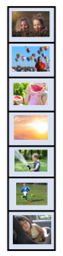
Teachers it is important that students use Chrome or Firefox as their browser. Not safari or explorer. Then follow these simple steps.
- Collect a series of photos of yourself, or others, engaging in all 7 It Takes 7 healthcare practices.
- Go to the 'Health Wheel' - 'Create Your Own' page. You will need to login or create a login to use the wheel. To upload your photos simply click on 'Choose file', select an image from your computer, assign the image to the correct title (Attitude, Air, etc) and save. Make sure your photos are 'still' photos, not 'live'. Live photos may distort when uploaded. Also, aim to have lots of background space in your image. This will make editing your photo on the wheel easier.
- When all seven images are uploaded, drag each image across and drop into the correct section of the wheel.
- Use the tools below the health wheel to make sure the images fit neatly in each section. If at first the tools don't appear to be working, keep trying. They sometimes take a few goes to click in.
- When finished, download your wheel. Save it! Share it!
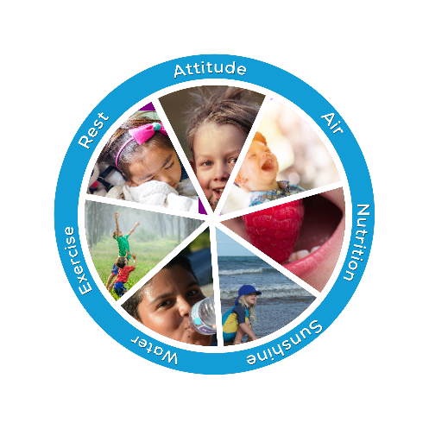
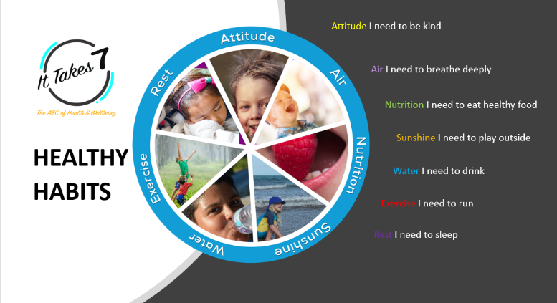

RESEARCH OPTION - Lesson 6 ongoing: Healthcare Poster
Students will decide who the poster is for: themselves, their family or their class? On their poster students will need to include:
- a health wheel they have created
- key facts about all 7 healthcare practices
- the It Takes 7 logo
PowerPoint or Publisher are stable programs for creating posters. Print it! Display it!
Reflection: Did the poster help your audience (you, your family or the class)? Survey the audience. What messages were most effective? Which healthcare practices were easiest to follow? Which were most challenging? Why? Add to or adapt this list of reflective questions.

Lesson 6 ongoing HEALTHCARE INVESTIGATION & RESEARCH
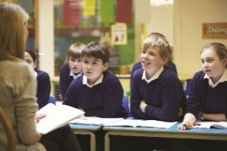
Year 4-6
Students should now have a better understanding of their own, and their classmates, holistic healthcare practices. The next step is to inspire them to further investigate It Takes 7 healthcare topics and conduct their own research. Students will have noticed ideas for research options at the end of each lesson. They may already have a project in mind they would like to pursue.
Investigation & Research
What is the difference between investigation and research?
Explain to your class an investigation is a searching inquiry where you look for the facts, record the details and carefully examine what you have found. Research is more a more systematic approach where you test the information you have investigated. In research you do not know the answer to your research question. The research is a method for finding out what you don’t know or for testing your hypothesis (something you think may be true).
Here is an example. You may choose as your health research assignment to make an It Takes 7 healthcare poster and test its effectiveness. Firstly, your investigation will involve talking to others about their healthcare practices and examining literature on healthcare. You will then decide on which healthcare messages seem most important for your audience (those who will view your poster). Your research might involve displaying the poster and keeping notes on how the poster has influenced the behaviour of those who have viewed the poster. You may ask them some survey questions like: Did they change their healthcare behaviours? How? Did they choose to ignore the healthcare messages? Why?
Getting started
Firstly, come up with some key research questions.
Secondly, discuss how they will go about finding reliable information for their investigation.
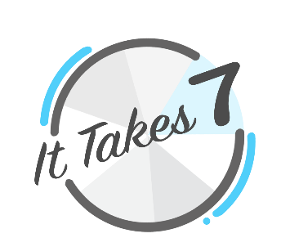
Thirdly, decide how they can gather data for their research, analyse it and present the findings to the class.
There are lots of ideas for investigation and research on the following page.


Investigation and research suggestions:
- Managing my Emotions: Create a poster showing how to use It Takes 7 healthcare practices to help you when you are faced with challenging situations. (Lesson 1, Part 1)
- Creative Video: Students create a video of themselves dancing to the song ‘Attitude is the ANSWER’. Describe the process. (Lesson 1, Part 2)
- The Body Puzzle: Do further healthcare investigations and make word search puzzles or board games. Did doing the puzzle or playing the board games help you or your friends learn, remember and act on important healthcare messages? (Lesson 1, Part 3)
- Media Review: Investigate media messages about healthcare. Examine 2-3 healthcare articles. Use the It Takes 7 healthcare wheel as a guide to tick off which healthcare practices are listed. Which healthcare messages are often highlighted? Which ones are generally overlooked? Is it important to have an ABC for health and wellbeing? (Lesson 2, Yr 4-6)
- Health Journal: After you have complete healthcare investigations, journal your It Takes 7 healthcare practices for 1-2 weeks. Start with a plan highlighting your goals (e.g. drink 6 cups of water a day) and aims (e.g. increase water intake). Review your journal at the end of 2 weeks and comment on your 'goals and misses' for each healthcare practice. Did you achieve your overall aim? (Lesson 3)
- Graphic Displays: Students choose a range of their class’s healthcare practices, highlighted in the Class Quiz, they would like to display in a graphic format. Students could use EXCEL and PowerPoint to present their data (Lesson 4)
- Healthcare Poster: After completing Lessons 1-5, make a class poster showing how to use It Takes 7 healthcare practices to help you throughout the school day. Did it work? Survey the class. What messages were the most effective? (Lesson 5)
- Group Research: Divide the class into 7 groups and each group investigates a specific element of the It Takes 7 ABC of health and wellbeing. What observations did you make of others engaging in that health element?
- Health Goals and Aims: Investigate a healthcare area you need to improve on which was highlighted when you completed your student health survey (Lesson 3). Create a plan about how you intend to improve on that healthcare practice. For example, goal - do 1 ½ hrs of exercise each day: aim - increase time exercising each day. Keep journal notes. And review your results after 1-2 weeks. How did you go?
- Animals: You are the expert. Investigate It Takes 7 healthcare practices for animals. Create a health wheel poster for a pet. Hang it somewhere so you can remember to attend to your pet’s needs or ask your vet if you can display it in their waiting room. What happened?
- Elite Athletes: You are the expert. Investigate It Takes 7 healthcare practices for elite athletes. Create a health wheel poster for an individual or group of athletes. Send it to them, request them to display it somewhere and ask if they would mind providing feedback. Did they use it? Did it help them make any changes to their healthcare practices? What else did they say?
- Healthy vs Unhealthy: You have done all the investigations. Show both sides of the coin. Healthy verses unhealthy choices for all 7 healthcare practices. Create your own survey questions and interview others about which side of the coin they most often represent?


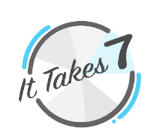
Student/Teacher Negotiation
Time to check in with your students. Find out what activity they would like to do and how they will go about their investigation and research. Discuss how they plan to present their findings and set a date for their presentation. Make sure you include an It Takes 7 health wheel and logo in your presentation. Have fun!!
Check out samples for an assessment rubric and student checklist. Adapt, personalise, be creative.
PRESENTATION
Show and Tell. Students display or present their findings to the class on an agreed date. You can also encourage them to present their work to their family, friends or other students at your school. Students should go through a check list to make sure they are ready to present their assignment to the class or hand their work into their teacher:
- Have I done everything my teacher outlined I needed to do for this assignment?
- Is my presentation clear and are the main points easy to find?
- Have I included an It Takes 7 health wheel and logo?
- Have I edited my work?
- Has someone else looked at, or listened to, my presentation?
- If doing an oral presentation, do I have my props or cue cards?
- Will students find my presentation interesting?
STUDENT REFLECTION
Time for students to think back on all they have done and learnt while engaging in this healthcare unit.

What activities did you enjoy doing most?
Name three new things you have learnt.
What else would have been good to include in this unit?
Draw a face to show how much you enjoyed this unit?
TEACHER REFLECTION
Time to think back on all you have done and learnt while running this healthcare unit.


What did you learn about your students?
Your teaching practice?
How well did you meet the curriculum objectives?
To what extent did students engage their general capabilities?
Were you able to link HPE cross-curriculum sustainability priorities to your unit?
How would you do this unit differently next time?
How can you follow up this learning experience?

Please note we would love to receive your feedback. We are happy to display samples of your student’s work on our website. Please forward to in@ittakes7.com.au
Links to ACARA
NOTE: It Takes 7 key acronymic saying Attitude is the ANSWER highlights the mental health and wellbeing focus of this program. Students learn ‘attitude’ or their ‘emotional states’ can drive their commitment to healthcare practices (ANSWER). In the same way, a commitment to holistic healthcare practices (ANSWER– Air, Nutrition, Sunshine, Water, Exercise, Rest) can improve their ‘attitude’. The aim is to help students find a strong position to deal with emotional conflicts, disappointments or stresses as they arise in their everyday lives.
This approach is based on a biopsychosocial/environmental healthcare model and is highlighted in these HPE elaborations:
- Year 1-2 ‘recognising own emotions and demonstrating positive ways to react in different situations’ (ACPPS020)
- Year 3-4 ‘recognising own emotional responses and levels of their response in different situations’ and ‘describing strategies they can use to identify and manage their emotions before making a decision’ (ACPPS038)
- Year 5-6 ‘exploring why emotional responses can be unpredictable’ (ACPPS056)
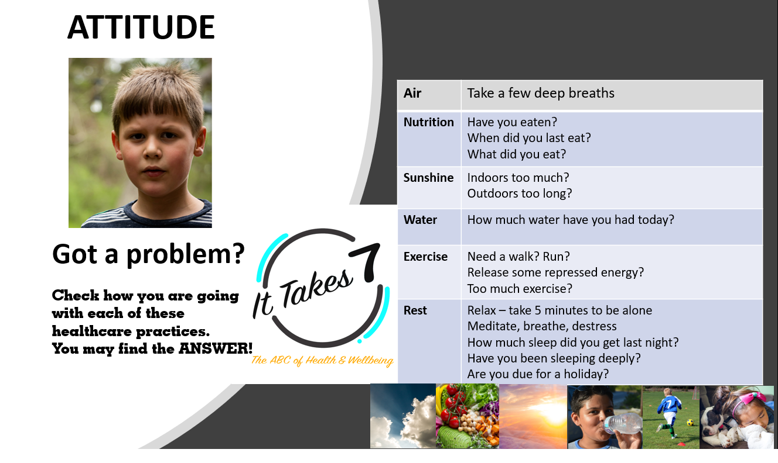

HEALTH and PHYSICAL EDUCATION
Content descriptors for Personal, Social and Community Health
Foundational Level
Identify actions that promote health, safety and wellbeing (ACPPS006)
Identify and describe emotional responses people may experience in different situations (ACPPS005)

Year 1-2
Recognise situations and opportunities to promote health, safety and wellbeing (ACPPS018)
Identify and practise emotional responses that account for own and others’ feelings (ACPPS020)
Examine health messages and how they relate to health decisions and behaviours (ACPPSO21)
Year 3-4
Identify and practise strategies to promote health, safety, and wellbeing (ACPPS036)
Investigate how emotional responses vary in depth and strength (ACPPS038)
Discuss and interpret health information and messages in the media and internet (ACPPS039)

Year 5-6
Plan and practise strategies to promote health, safety and wellbeing (ACPPS054)
Exploring why emotional responses can be unpredictable (ACPPS056)
Recognise how media and important people in the community influence personal attitudes, beliefs, decisions and behaviours (ACPPS0570)
Investigate the role of preventive health in promoting and maintaining health, safety and wellbeing for individuals and their communities (ACPPS058)
Focus areas in health include:
- food and nutrition (FN)
- health benefits of physical activity (HBPA)
- mental health and wellbeing (MH)
- safety (S)
GENERAL CAPABILITIES
Critical and reflective thinking, personal and social capability, literacy, ethical understanding, information and communication technology.
Students use ICT as key tools for communicating, collaborating, creating content, seeking help, and accessing information in the health and physical education field.
CROSS CURRICULUM PRIORITIES – SUSTAINABILITY

Health and Physical Education

It is important for students to contextualise their own healthcare practices in terms of their connections and interactions with natural, managed and built environments, and with people in different social groups within their social networks and wider comm unities. Considering how these connections and interactions within systems play an important role in promoting, supporting and sustaining the wellbeing of individuals, the community and the environment as a whole, is also importantly juxtaposed with a present and futures perspective.

Students develop their world view by exploring concepts of diversity, social justice and consumerism as these relate to the promotion and maintenance of health and wellbeing. Through movement experiences, students are provided with opportunities to develop a connection in and with environments and to gain an appreciation of the interdependence of the health of people and that of environments.

NUMERACY - Statistics and Probability
Students collect data by asking questions, drawing data displays and making inferences. Year 3-6 with or without the use of technology.
Foundational
Answer yes/no questions to collect information and make simple inferences (ACMSP011)

Year 1
Choose simple questions and gather responses and make simple inferences (ACMSP262)
Represent data with objects and drawings where one object or drawing represents one data value. Describe the displays (ACMSP263)

Year 2
Identify a question of interest based on one categorical variable. Gather data relevant to the question (ACMSP048)
Collect, check and classify data (ACMSP049)
Create displays of data using lists, table and picture graphs and interpret them (ACMSP050)

Year 3
Identify questions or issues for categorical variables. Identify data sources and plan methods of data collection and recording (ACMSP068)
Collect data, organise into categories and create displays using lists, tables, picture graphs and simple column graphs, with and without the use of digital technologies (ACMSP069)
Interpret and compare data displays (ACMSP070)

Year 4
Construct suitable data displays, with and without the use of digital technologies, from given or collected data. Include tables, column graphs and picture graphs where one picture can represent many data values (ACMSP096)
Evaluate the effectiveness of different displays in illustrating data features including variability (ACM SP097)

Year 5
Construct displays, including column graphs, dot plots and tables, appropriate for data type, with and without the use of digital technologies (ACMSP119)
Describe and interpret different data sets in context (ACMSP120)

Year 6
Interpret and compare a range of data displays, including side-by-side column graphs for two categorical variables (ACMSP147)

